Submitted by Rajendra Bichu(Week 20) – Low code using FlowWise

Contents
Objective 2
Project Objective 2
Approach Followed for this Assignment 2
Task 1 – Data Setup 5
Task 2 – Create the Query Chain 5
Task 3 – Add Conversational Memory 5
Task 4 – Customisation and Testing (Results) are as attached 5
Deliverables 5
Lessons Learnt were as below : 8
Questions and the Answers as Captured 9
Task 4 – Customisation and Testing 15

Objective

This Week 20 Graded Mini Project asks you to build a Flowise-powered jewellery retail chatbot for a fictional brand, Ornativa Jewels (Hyderabad, India). The chatbot must answer customer questions by reading and using the product catalogue provided in Jewellery Details.pdf. The goal is to practise building a retrieval-based chatbot using a visual pipeline (document loading, chunking, embeddings, retrieval, prompting, memory, and testing) without relying on hard-coded answers.

Project Objective
Your objective is to create and test a Jewellery Chatbot that:
- answers customer questions using the catalogue content provided in Jewellery Details.pdf,
- supports follow-up questions using short-term conversation context (memory),
- remains polite, concise, and factual in tone,
- and suggests a relevant alternative when an item is out of stock (based on the catalogue).

Approach Followed for this Assignment
- Data is uploaded as per the Jwellery data which is given , I have also added few more records from Kaggle to have more robust data
- Flow Wise was used as a LowCode Tool
  - Account was created : https://cloud.flowiseai.com/canvas/b1a07bf2-fce0-404e-8a5f-6ca314e1851a
  - Flow was created
  - Flow diagram screenshot as below.
  - Upsert was used inside the Flow wise to attach and insert the data from Jwellery Details
  - Customize queries were executed for 5-10 queries
- Data was store in PineCone Vector Store and Created an Index as below
  - Index was Dense and Cosine
  - Embedding was higher one
- 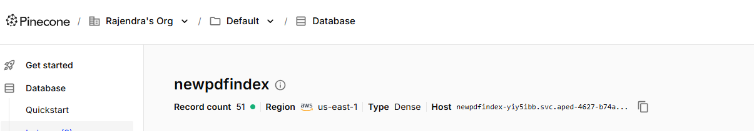

- 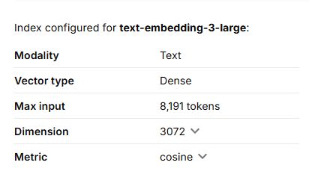

Task 1 – Data Setup
- Refer to the Flow Diagram as attached
- Pinecone Account was Setup as a Vector Store
- Upsert was done for the Jwellery PDF
- https://app.pinecone.io/organizations/-OqPklJlgBHgaRzW9r80/projects/4fca2f08-0ebd-4bab-9ada-f6269d10c4f4/indexes
- Index was created for PineCone
- 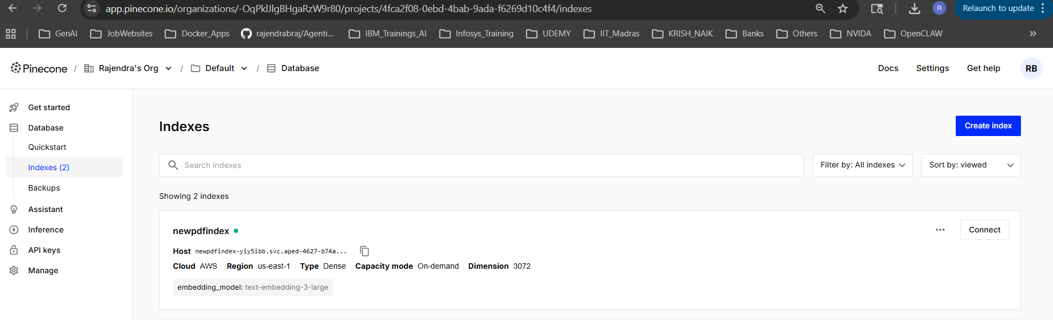

Task 2 – Create the Query Chain - Refer to the Flow Diagram as attached

Task 3 – Add Conversational Memory - Refer to the Flow Diagram as attached

Task 4 – Customization and Testing (Results) are as attached as below.
Refer to the Flow Diagram as attached

Deliverables
- Flowise chatflow export (JSON), or a clearly captured set of screenshots showing the full node pipeline and connections. (Added in the screenshot) (JSON I will also attach)

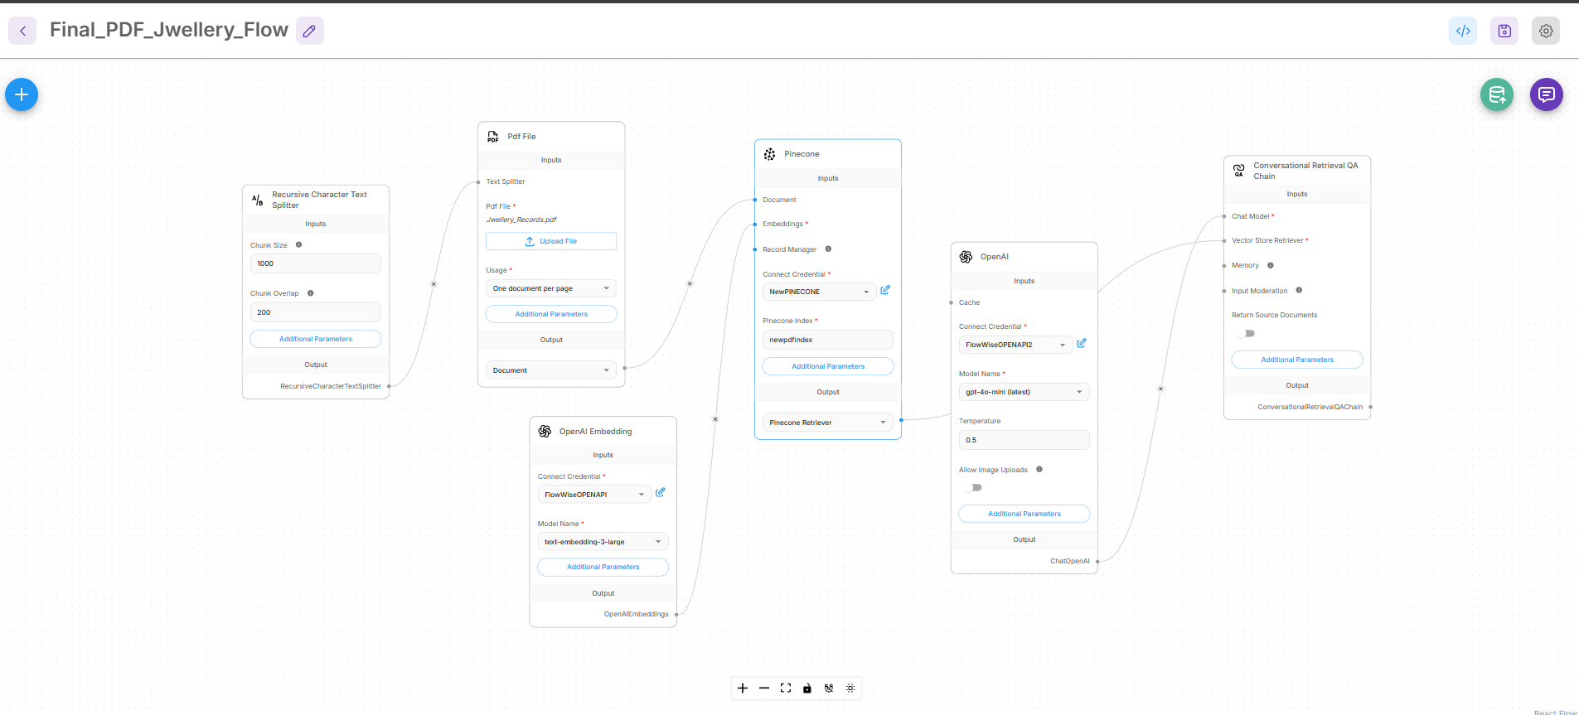

- Test evidence: at least five user queries with the chatbot’s responses (screenshots or copied logs). (Added in the screenshot and text as below)
- Short write-up (README or PDF) describing: your node choices, chunking approach, prompt design, memory setup, and how you handled out-of-stock suggestions. (Approach as above and Summary)

Lessons Learnt were as below :
- I have explored FlowWise and N8n as both tools.
- Pinecone connectivity is not simple you have to have index configuration correct
- FlowWise allows you only max 2 flows in the Starter version (Free Version)
- Debugging in Flow wise is not very easier to perform within FlowWise
- N8n Debugging is easier, this can be an alternative tool
- Nodes connected are and their respective Roles in (FLOW WISE)
  - PDF file to attach and Upsert the records
  - Recursive Character Text Splitter to have 1000:200 Text Splitting
  - Open AI Embedding to have embeddings created
  - Pinecone as Vector Store
  - Conversational Retrieval QA Chain to Query the Chatbot to get Jewelry details
  - Please note I have added extra data also so that the data is more and Robust apart from existing records given, some improvisation.

Questions and the Answers as Captured

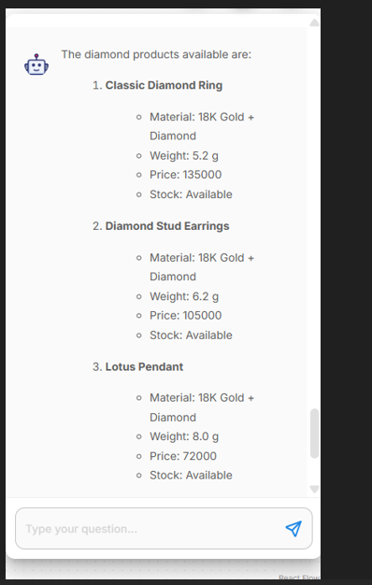

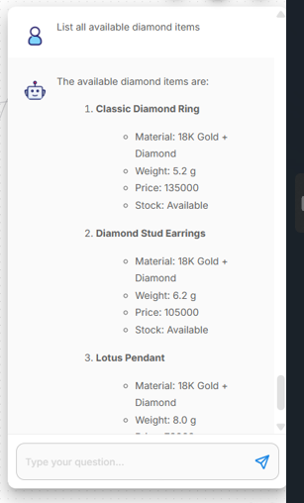

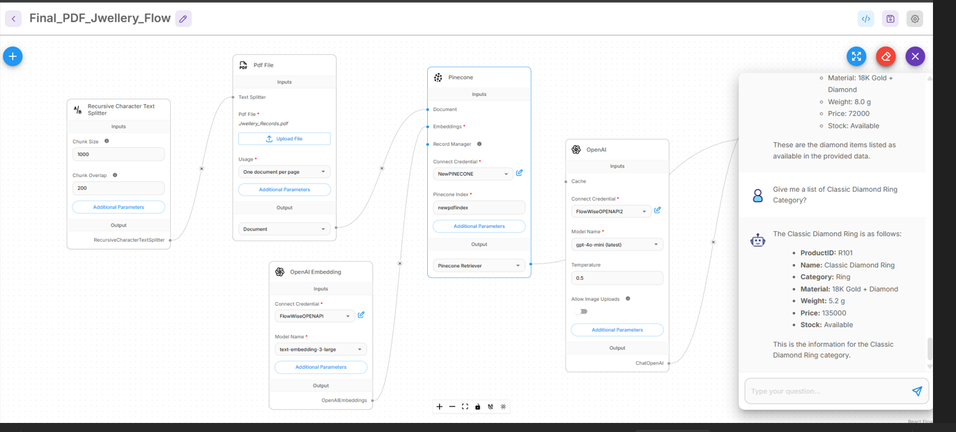

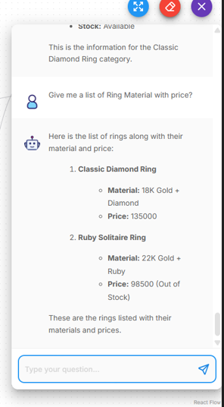
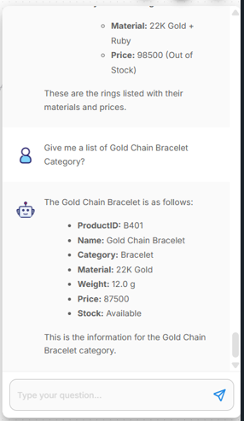

Questions and Answers as attached (ScreenShots)
what is the price of Double Butterfly Pendant ?
what is the price of Rose Pendant ?
what is the price of Kitty Pendant ?
Give me data about Rose Pendant , kitty Pendant, Double Butterfly Pendant?
show me classic diamond ring category
show me necklace material and chain materials
show me ring category all records
show me bracelet category

Give me a list of Classic Diamond Ring Category?
Give me a list of Ring Material with price?
Give me a list of Gold Chain Bracelet Category?
Give me a list of Emerald Cuff Bracelet Category?
Give me a list of Lotus Pendant Category?
Give me a list of Lotus Pendant Category with price?

You are Ornativa’s virtual jewellery expert. Be polite, concise, and factual.Show me diamond products.
You are Ornativa’s virtual jewellery expert. Be polite, concise, and factual. Do you have enough stock of diamond rings?
You are Ornativa’s virtual jewellery expert. Be polite, concise, and factual. What’s the price of the ring?
You are Ornativa’s virtual jewellery expert. Be polite, concise, and factual. What is the price of the Pearl Necklace?
You are Ornativa’s virtual jewellery expert. Be polite, concise, and factual. Which products are made of 22K gold?

Show me diamond products
What’s the price of the ring?
List all available diamond items.
What is the price of the Pearl Necklace?
Which products are made of 22K gold?
Do you have platinum bangles?
Do you sell watches?

Task 4 – Customisation and Testing

Text output of the chatbot is copied here as below for questions asked and data retrieved
Customise the system prompt to reflect the brand’s tone, e.g.:
“You are Ornativa’s virtual jewellery expert. Be polite, concise, and factual.”
Test at least five queries, including price, material, category, and stock-related questions.
If an item is out of stock, configure the chatbot to suggest an alternative product. Example:
“Ruby Solitaire Ring is currently out of stock. You may like the Classic Diamond Ring instead.”

Flow Wise Queries (Testing)
==============================================
Show me diamond products

AI
The diamond products available are:

Classic Diamond Ring

Material: 18K Gold + Diamond
Weight: 5.2 g
Price: 135000
Stock: Available
Diamond Stud Earrings

Material: 18K Gold + Diamond
Weight: 6.2 g
Price: 105000
Stock: Available
Lotus Pendant

Material: 18K Gold + Diamond
Weight: 8.0 g
Price: 72000
Stock: Available
These are the diamond products listed in the provided data.

Type your question...

==============================================

Which products are made of 22K gold?

AI
The products made of 22K gold are:

Gold Chain Bracelet

ProductID: B401
Weight: 12.0 g
Price: 87500
Stock: Available
Ruby Solitaire Ring

ProductID: R102
Weight: 4.8 g
Price: 98500
Stock: Out of Stock
Emerald Choker

ProductID: N202
Weight: 32.0 g
Price: 310000
Stock: Available
Daily Wear Gold Earrings

ProductID: E301
Weight: 7.5 g
Price: 55000
Stock: Available
Om Symbol Pendant

ProductID: P502
Weight: 6.5 g
Price: 48000
Stock: Available
These are the products made of 22K gold listed in the provided data.

Type your question...

=================================================

Show me diamond products

AI
The diamond products available are:

Classic Diamond Ring

Material: 18K Gold + Diamond
Weight: 5.2 g
Price: 135000
Stock: Available
Diamond Stud Earrings

Material: 18K Gold + Diamond
Weight: 6.2 g
Price: 105000
Stock: Available
Lotus Pendant

Material: 18K Gold + Diamond
Weight: 8.0 g
Price: 72000
Stock: Available
These are the diamond products listed in the provided data.

Me
what is the price of Double Butterfly Pendant

AI
The price of the Double Butterfly Pendant is INR 799.

Me
List all available diamond items

AI
The available diamond items are:

Classic Diamond Ring

Material: 18K Gold + Diamond
Weight: 5.2 g
Price: 135000
Stock: Available
Diamond Stud Earrings

Material: 18K Gold + Diamond
Weight: 6.2 g
Price: 105000
Stock: Available
Lotus Pendant

Material: 18K Gold + Diamond
Weight: 8.0 g
Price: 72000
Stock: Available
These are the diamond items listed as available in the provided data.

Me
List all available diamond items

AI
The available diamond items are:

Classic Diamond Ring

Material: 18K Gold + Diamond
Weight: 5.2 g
Price: 135000
Stock: Available
Diamond Stud Earrings

Material: 18K Gold + Diamond
Weight: 6.2 g
Price: 105000
Stock: Available
Lotus Pendant

Material: 18K Gold + Diamond
Weight: 8.0 g
Price: 72000
Stock: Available
These are the diamond items listed as available in the provided data.

Me
Give me a list of Classic Diamond Ring Category?

AI
The Classic Diamond Ring is as follows:

ProductID: R101
Name: Classic Diamond Ring
Category: Ring
Material: 18K Gold + Diamond
Weight: 5.2 g
Price: 135000
Stock: Available
This is the information for the Classic Diamond Ring category.

Me
Give me a list of Ring Material with price?

AI
Here is the list of rings along with their material and price:

Classic Diamond Ring

Material: 18K Gold + Diamond
Price: 135000
Ruby Solitaire Ring

Material: 22K Gold + Ruby
Price: 98500 (Out of Stock)
These are the rings listed with their materials and prices.

Me
Give me a list of Gold Chain Bracelet Category?

AI
The Gold Chain Bracelet is as follows:

ProductID: B401
Name: Gold Chain Bracelet
Category: Bracelet
Material: 22K Gold
Weight: 12.0 g
Price: 87500
Stock: Available
This is the information for the Gold Chain Bracelet category.

Me
show me classic diamond ring category

AI
The Classic Diamond Ring is as follows:

ProductID: R101
Name: Classic Diamond Ring
Category: Ring
Material: 18K Gold + Diamond
Weight: 5.2 g
Price: 135000
Stock: Available
This is the information for the Classic Diamond Ring category.

Me
Which products are made of 22K gold?

AI
The products made of 22K gold are:

Gold Chain Bracelet

ProductID: B401
Weight: 12.0 g
Price: 87500
Stock: Available
Ruby Solitaire Ring

ProductID: R102
Weight: 4.8 g
Price: 98500
Stock: Out of Stock
Emerald Choker

ProductID: N202
Weight: 32.0 g
Price: 310000
Stock: Available
Daily Wear Gold Earrings

ProductID: E301
Weight: 7.5 g
Price: 55000
Stock: Available
Om Symbol Pendant

ProductID: P502
Weight: 6.5 g
Price: 48000
Stock: Available
These are the products made of 22K gold listed in the provided data.

=================================================================================
show me necklace material and chain materials

AI
The necklace materials and chain materials listed are:

Necklace Material: 18K White Pearl, Onyx, set with a brilliant-cut diamond of 0.02 carats.
Chain Material: Adjustable chain (specific material not provided in the data).
If you need more specific details or additional items, please let me know!

=================================================================================

Do you have platinum bangles?

AI
Hmm, I'm not sure.

Me
Do you have platinum bangles?

AI
Hmm, I'm not sure.

Give me a list of Emerald Cuff Bracelet Category?

AI
The Emerald Cuff Bracelet is as follows:

ProductID: B402
Name: Emerald Cuff Bracelet
Category: Bracelet
Material: 18K Gold
Emerald Weight: 15.0 g
Price: 150000
Stock: Out of Stock
This is the information for the Emerald Cuff Bracelet category.

You are Ornativa’s virtual jewellery expert. Do you have enough stock of diamond rings?

AI
Yes, there is enough stock of the Classic Diamond Ring, which is available. However, the Ruby Solitaire Ring is currently out of stock.

Me
You are Ornativa’s virtual jewellery expert. Be polite, concise, and factual. What’s the price of the ring?

AI
The price of the Classic Diamond Ring is INR 135000.

Me
You are Ornativa’s virtual jewellery expert. Be polite, concise, and factual. What is the price of the Pearl Necklace?

AI
I'm sorry, but I don't have information on the price of the Pearl Necklace.

Me
You are Ornativa’s virtual jewellery expert. Be polite, concise, and factual. Which products are made of 22K gold?

AI
The products made of 22K gold are:

Gold Chain Bracelet

Price: 87500
Stock: Available
Ruby Solitaire Ring

Price: 98500
Stock: Out of Stock
Emerald Choker

Price: 310000
Stock: Available
Daily Wear Gold Earrings

Price: 55000
Stock: Available
Om Symbol Pendant

Price: 48000
Stock: Available
Me
Give me a list of Emerald Cuff Bracelet Category?

AI
The Emerald Cuff Bracelet is as follows:

ProductID: B402
Name: Emerald Cuff Bracelet
Category: Bracelet
Material: 18K Gold
Emerald Weight: 15.0 g
Price: 150000
Stock: Out of Stock
This is the information for the Emerald Cuff Bracelet category.

Me
Give me a list of Gold Chain Bracelet Category?

AI
The Gold Chain Bracelet is as follows:

ProductID: B401
Name: Gold Chain Bracelet
Category: Bracelet
Material: 22K Gold
Weight: 12.0 g
Price: 87500
Stock: Available
This is the information for the Gold Chain Bracelet category.

Me
Give me a list of Ring Material with price?

AI
Here is the list of rings along with their material and price:

Classic Diamond Ring

Material: 18K Gold + Diamond
Price: 135000
Ruby Solitaire Ring

Material: 22K Gold + Ruby
Price: 98500 (Out of Stock)
These are the rings listed with their materials and prices.

Me
Give me a list of Classic Diamond Ring Category?

AI
The Classic Diamond Ring is as follows:

ProductID: R101
Name: Classic Diamond Ring
Category: Ring
Material: 18K Gold + Diamond
Weight: 5.2 g
Price: 135000
Stock: Available
This is the information for the Classic Diamond Ring category.

=================================================================================

